AWS 3-Tier Architecture

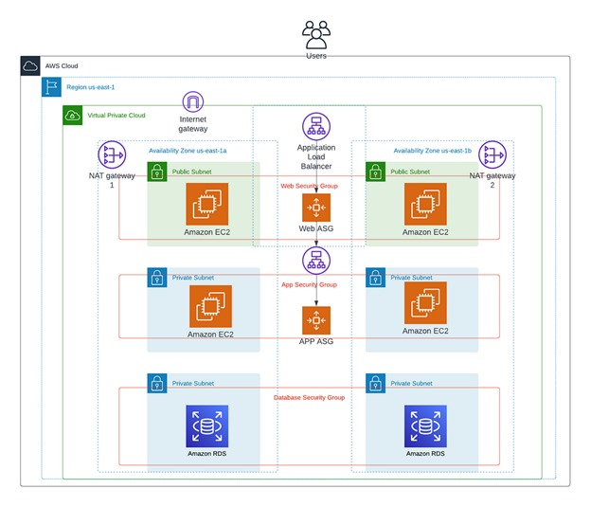

Creation of one VPC by opening the VPC service:-

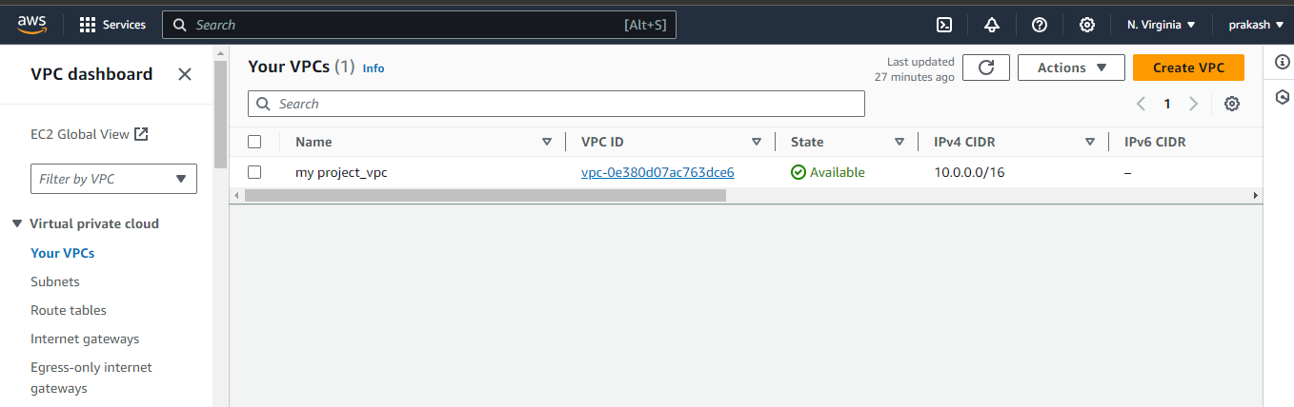

Create the 2 public subnets & 4 private subnets

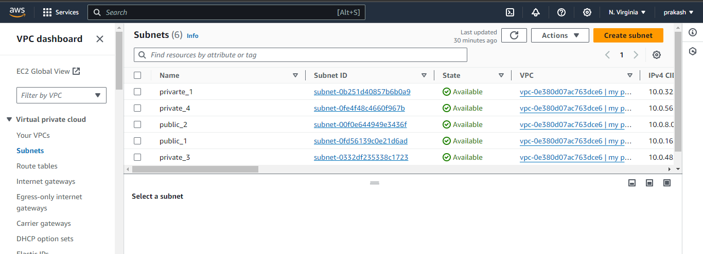

Create route tables of public & private

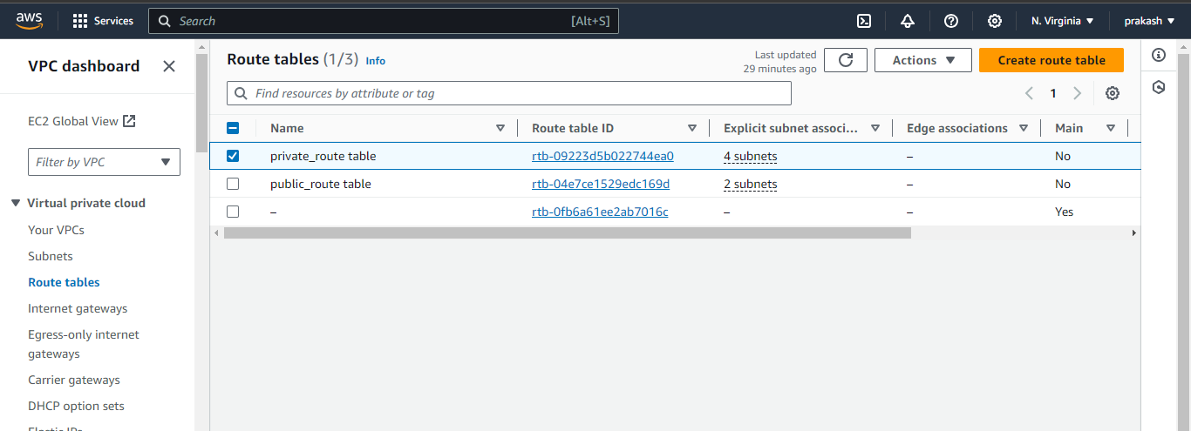

Subnet associations for public & private routes

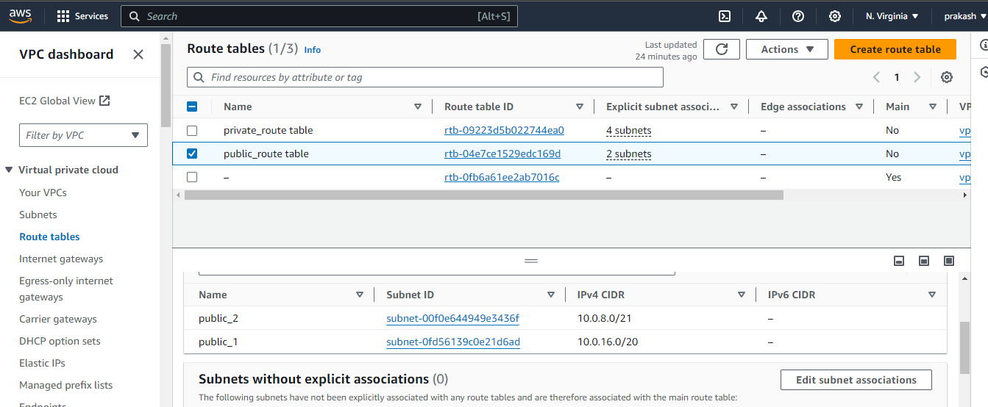

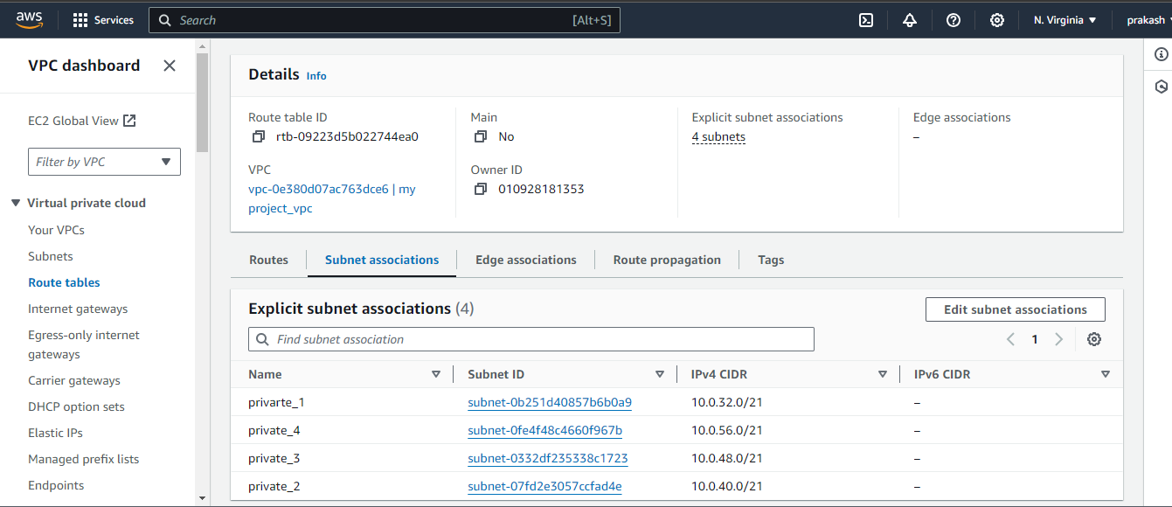

Connecting internet gateway to routes:-

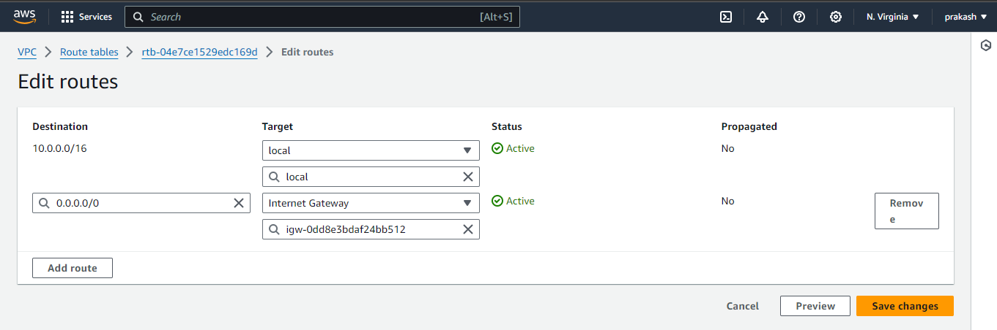

Connecting NAT gateway to routes:-

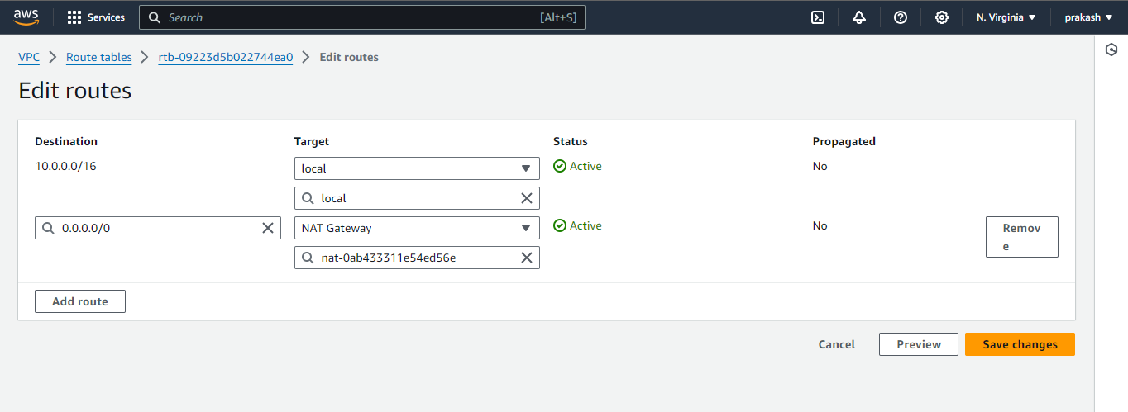

Creation of Security group with user defined name:-

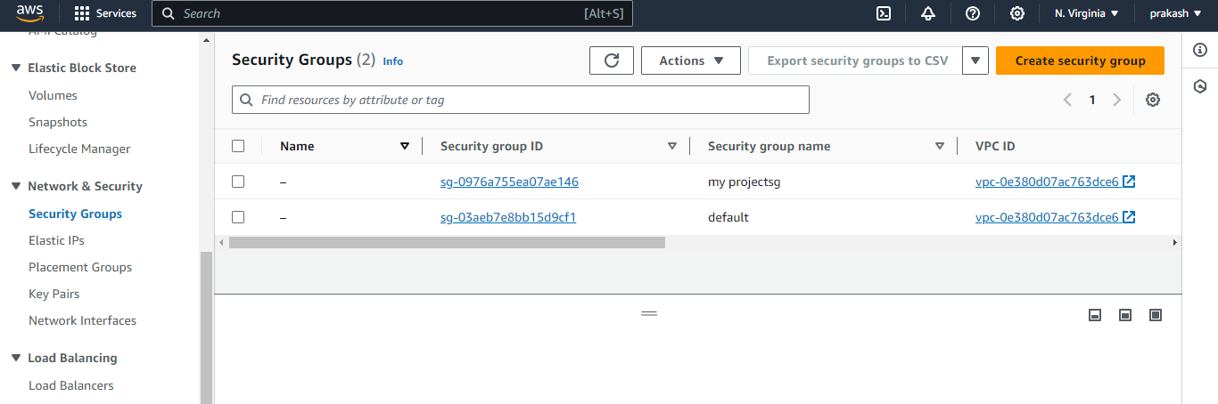

Create the launch template of public and private :-

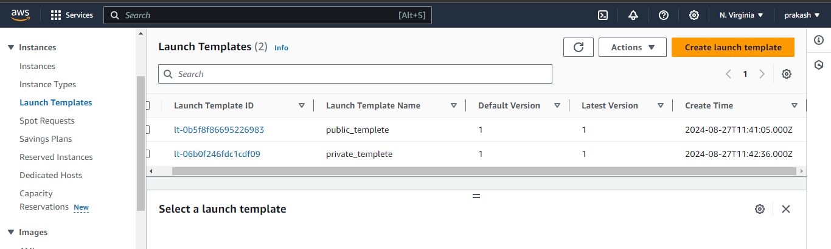

Create AUTO Scaling:-

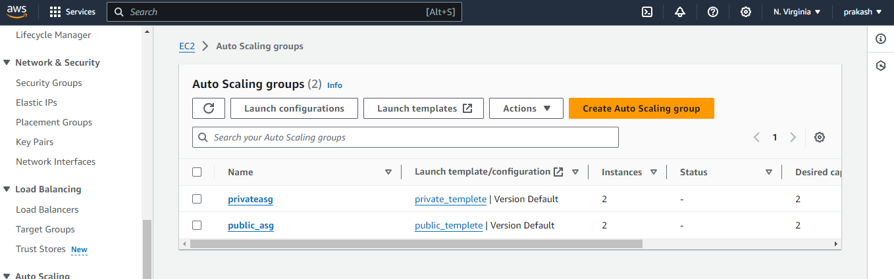

Through the auto scaling create the load balancer:-

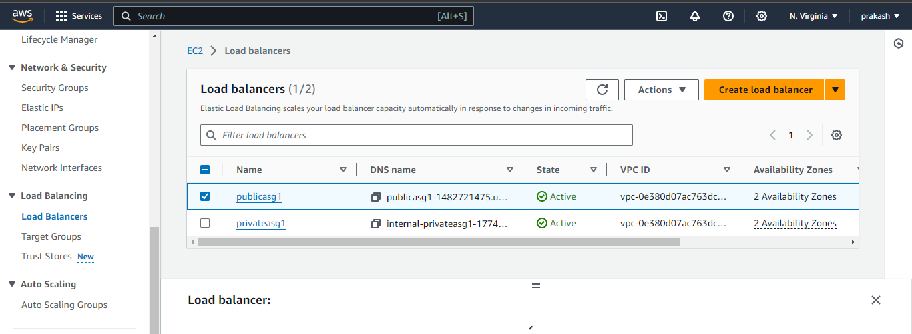

Creating the Target group of public & private:-

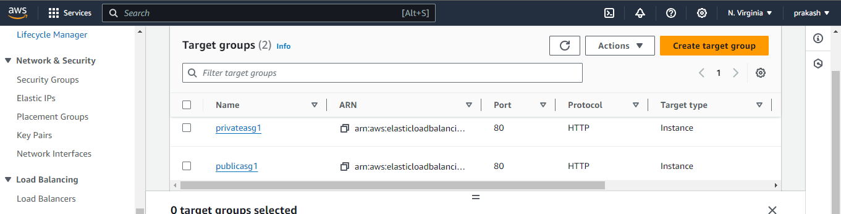

Create the database using the RDS service:-

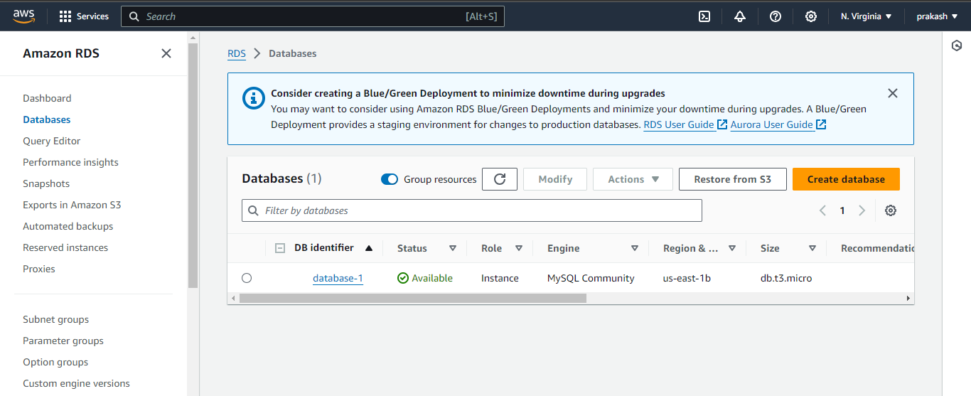

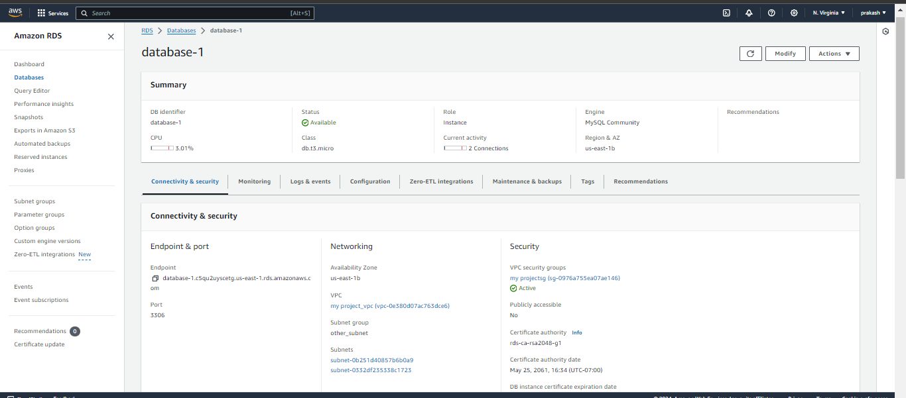

Through the RDS EC2 instance is created automatically:-

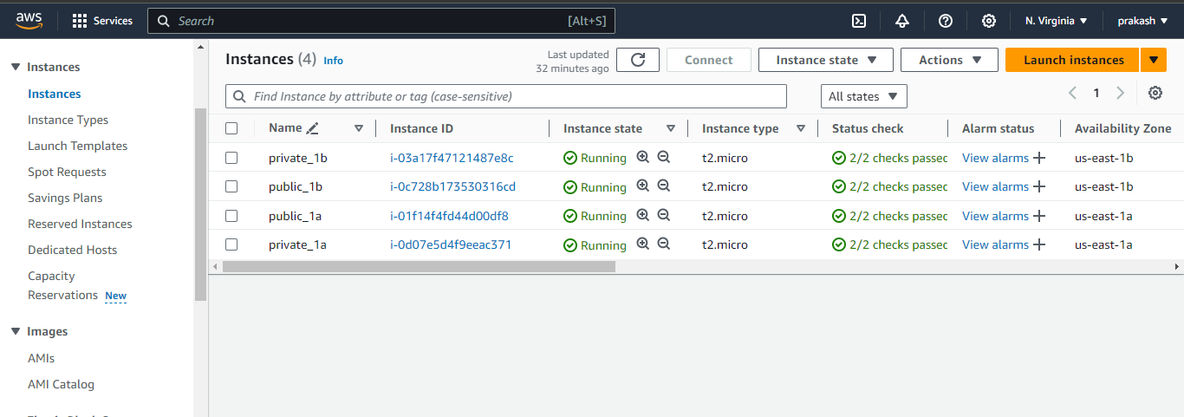

Take the one public instance and connect to the private instance :-

Take ssh of public and paste it in the git bash & become as the root user by giving the command sudo –i

Then take the ssh and add the private address to it .

It will connect to the private instance.

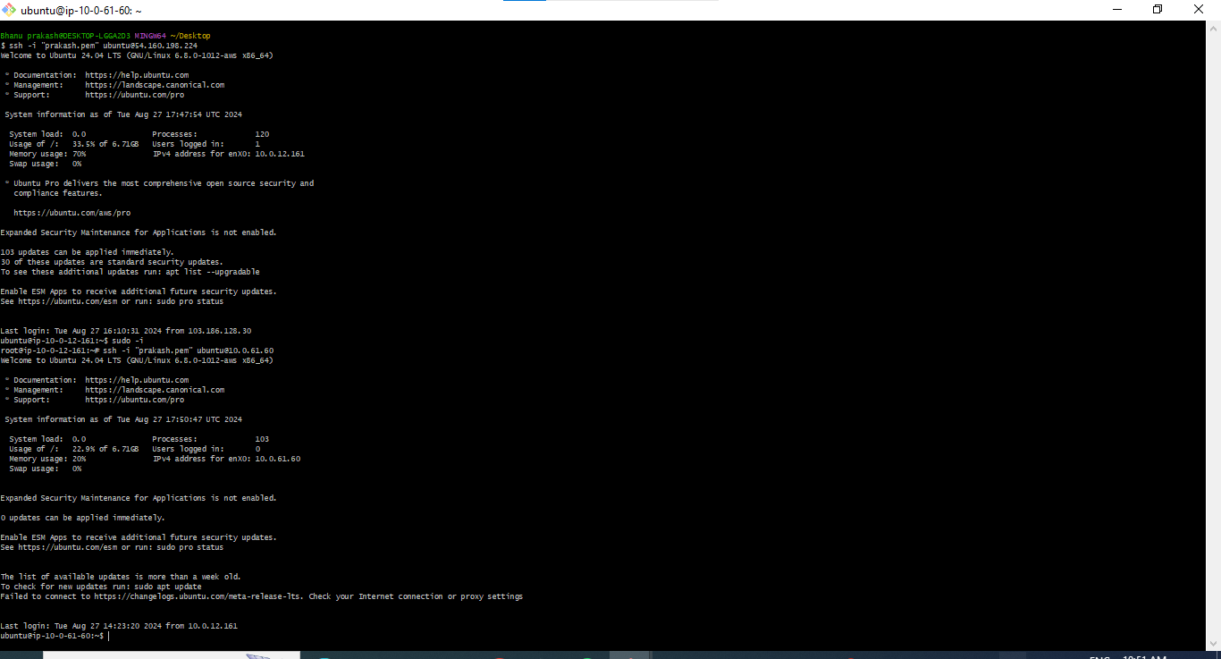

Install my sql through the git using the commands:-

Sudo –i && apt update –y && apt install mysql -y && sudo systemctl start mysql.service && chmod 400 pem file name. && mysql -h database-1.(endpoint address of rds) –u admin –p

Enter password:-

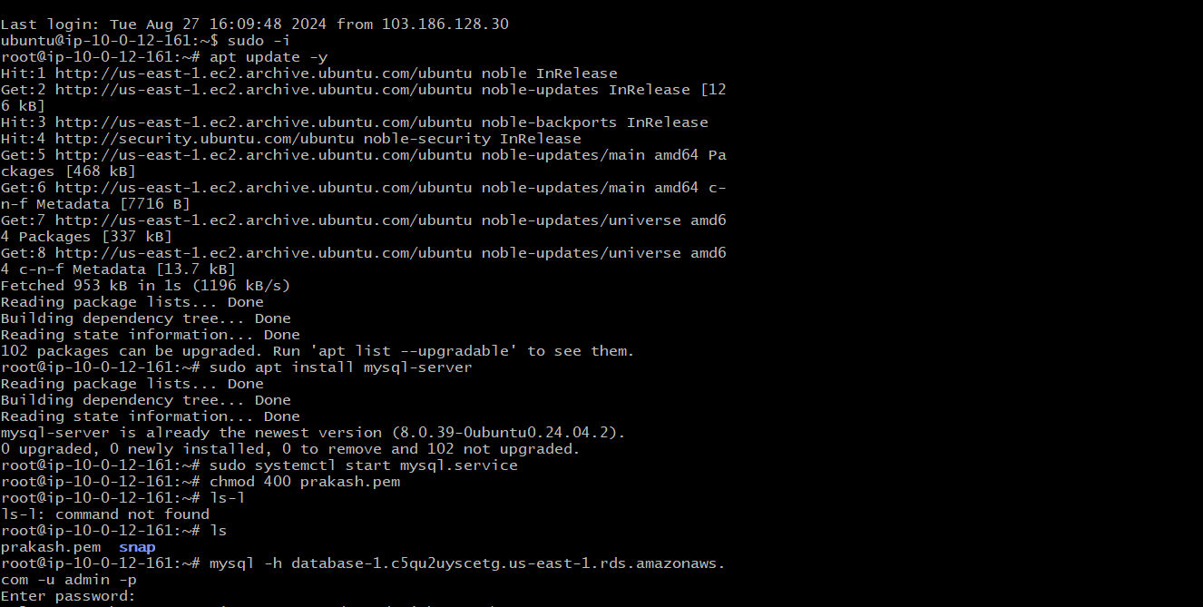

Connecting to the sql server and create the table in the database

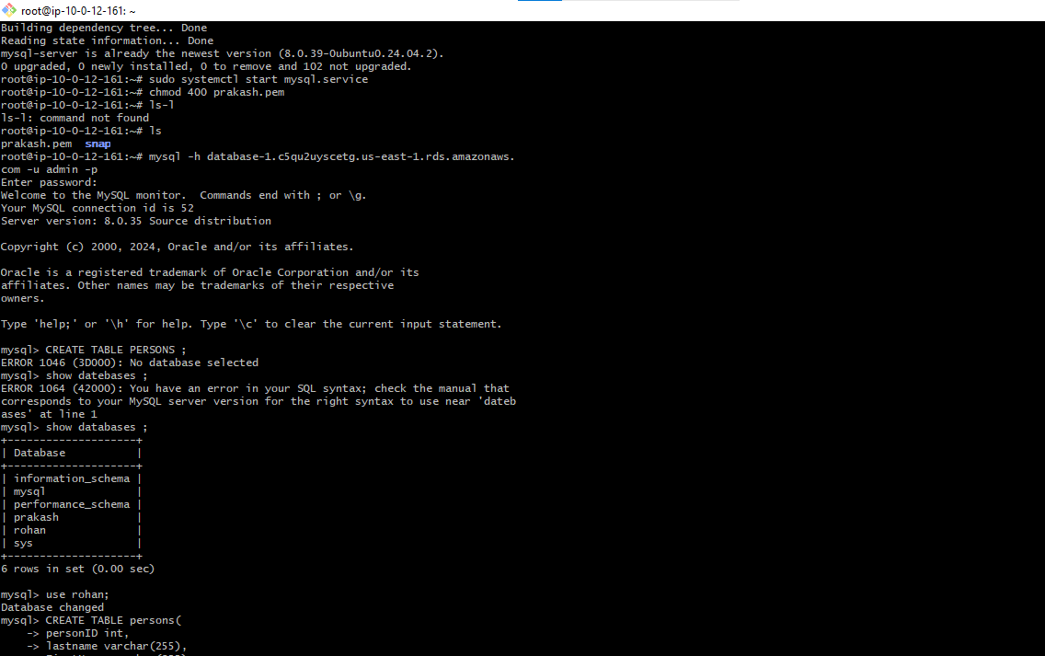

Inserting the values into the tables:-

